Flowsheet of working with EpiData Analysis
EpiData Association. Http://ww.epidata.dk JM.Lauritsen. V. nov 2005

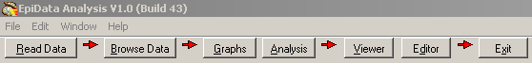

A simplified flowsheet of how EpiData Analysis is working. Blue parts are optional, black parts are in memory and red parts save permanently to disk. Note that the programme always works with a copy of data. Your data on the disk are not changed unless you as a user instruct the programme to do so. Note also that the commands issued are saved when you exit.

Keep a COPY of data in memory

Read a data file
(REC, DBF, CSV)
For REC files: Read variable labels in Rec File and category label and missing value definitions
in associated CHK file
Add new variables generate or define commands

Change contents of variables
let, recode
if ... then ...,

Change sorting
sort command
Modify data in memory

Save data to disk
Command savedata

Show results on the Screen

Copy of results written to disk. Default name EAOutput.htm

Close: logclose
”Next” Analysis command
Stop Analysis
quit or exit

A copy of all commands are saved as temp.pgm

